Q1.

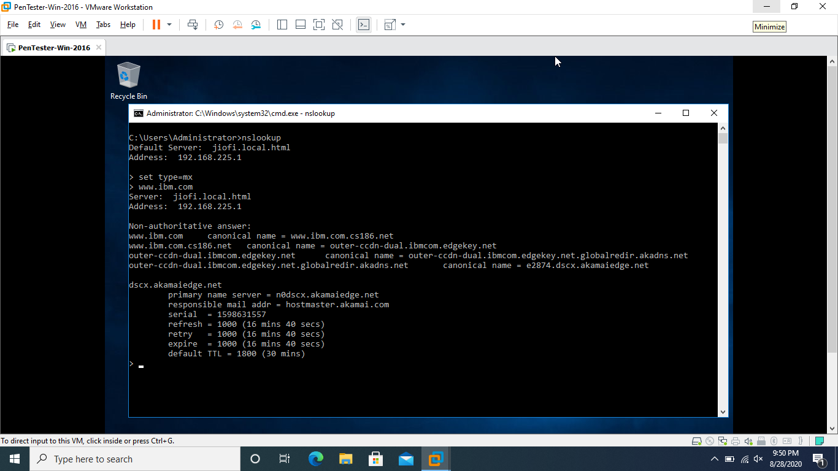



Q3.

root@kali-pc-001:~# nmap -Pn -sS -A -v 203.163.246.23

Starting Nmap 7.80 ( https://nmap.org ) at 2020-08-28 10:33 PDT

NSE: Loaded 151 scripts for scanning.

NSE: Script Pre-scanning.

Initiating NSE at 10:33

Completed NSE at 10:33, 0.00s elapsed

Initiating NSE at 10:33

Completed NSE at 10:33, 0.00s elapsed

Initiating NSE at 10:33

Completed NSE at 10:33, 0.00s elapsed

Initiating Parallel DNS resolution of 1 host. at 10:33

Completed Parallel DNS resolution of 1 host. at 10:33, 0.13s elapsed

Initiating SYN Stealth Scan at 10:33

Scanning 203.163.246.23 [1000 ports]

SYN Stealth Scan Timing: About 15.10% done; ETC: 10:36 (0:02:54 remaining)

SYN Stealth Scan Timing: About 30.05% done; ETC: 10:36 (0:02:22 remaining)

SYN Stealth Scan Timing: About 45.05% done; ETC: 10:36 (0:01:51 remaining)

SYN Stealth Scan Timing: About 60.05% done; ETC: 10:36 (0:01:20 remaining)

SYN Stealth Scan Timing: About 75.05% done; ETC: 10:36 (0:00:50 remaining)

Completed SYN Stealth Scan at 10:36, 201.36s elapsed (1000 total ports)

Initiating Service scan at 10:36

Initiating OS detection (try #1) against 203.163.246.23

Retrying OS detection (try #2) against 203.163.246.23

Initiating Traceroute at 10:36

Completed Traceroute at 10:36, 9.08s elapsed

Initiating Parallel DNS resolution of 6 hosts. at 10:36

Completed Parallel DNS resolution of 6 hosts. at 10:36, 0.09s elapsed

NSE: Script scanning 203.163.246.23.

Initiating NSE at 10:36

Completed NSE at 10:36, 0.02s elapsed

Initiating NSE at 10:36

Completed NSE at 10:36, 0.00s elapsed

Initiating NSE at 10:36

Completed NSE at 10:36, 0.00s elapsed

Nmap scan report for 203.163.246.23

Host is up (0.14s latency).

All 1000 scanned ports on 203.163.246.23 are filtered

Warning: OSScan results may be unreliable because we could not find at least 1 open and 1 closed port

Aggressive OS guesses: Cisco Adaptive Security Appliance (ASA 9.2) (96%), Synology RT1900ac router (96%), Asus RT-53N WAP (95%), Cisco Adaptive Security Appliance 5510 or 5540 firewall (ASA 8.0) (95%), Cisco ACE load balancer (95%), Cisco 3925 router (IOS 12.4) (95%), Cisco 3550 switch (IOS 12.2) (95%), Cisco ASA 5510 firewall (PIX OS 8.2) (95%), Foundry Networks BigIron 8000 switch (IronWare 07.8.02eT53) (95%), Linux 2.6.32 (95%)

No exact OS matches for host (test conditions non-ideal).

TRACEROUTE (using proto 1/icmp)

HOP RTT ADDRESS

1 5.07 ms jiofi.local.html (192.168.225.1)

2 ...

3 147.56 ms 10.71.168.82

4 147.70 ms 192.168.4.180

5 147.85 ms 192.168.4.183

6 148.00 ms 172.26.8.13

7 148.06 ms 172.25.7.84

8 ... 30

NSE: Script Post-scanning.

Initiating NSE at 10:36

Completed NSE at 10:36, 0.00s elapsed

Initiating NSE at 10:36

Completed NSE at 10:36, 0.00s elapsed

Initiating NSE at 10:36

Completed NSE at 10:36, 0.00s elapsed

Read data files from: /usr/bin/../share/nmap

OS and Service detection performed. Please report any incorrect results at https://nmap.org/submit/ .

Nmap done: 1 IP address (1 host up) scanned in 219.89 seconds

Raw packets sent: 2120 (96.496KB) | Rcvd: 8 (456B)

root@kali-pc-001:~#